Project Design Phase-II
Technology Stack (Architecture & Stack)
Date | 03 October 2026
Team ID | SWTID-2026-7282
Project Name | Implement Client Script & UI Policy (Incident)
Maximum Marks | 4 Marks
Technical Architecture:
The deliverable includes the architectural diagram and the component and application characteristics information for the ServiceNow Incident form implementation.
Architecture Diagram:
Architecture note: Client Scripts and UI Policies operate in parallel on the Incident form; neither is shown as calling the other.
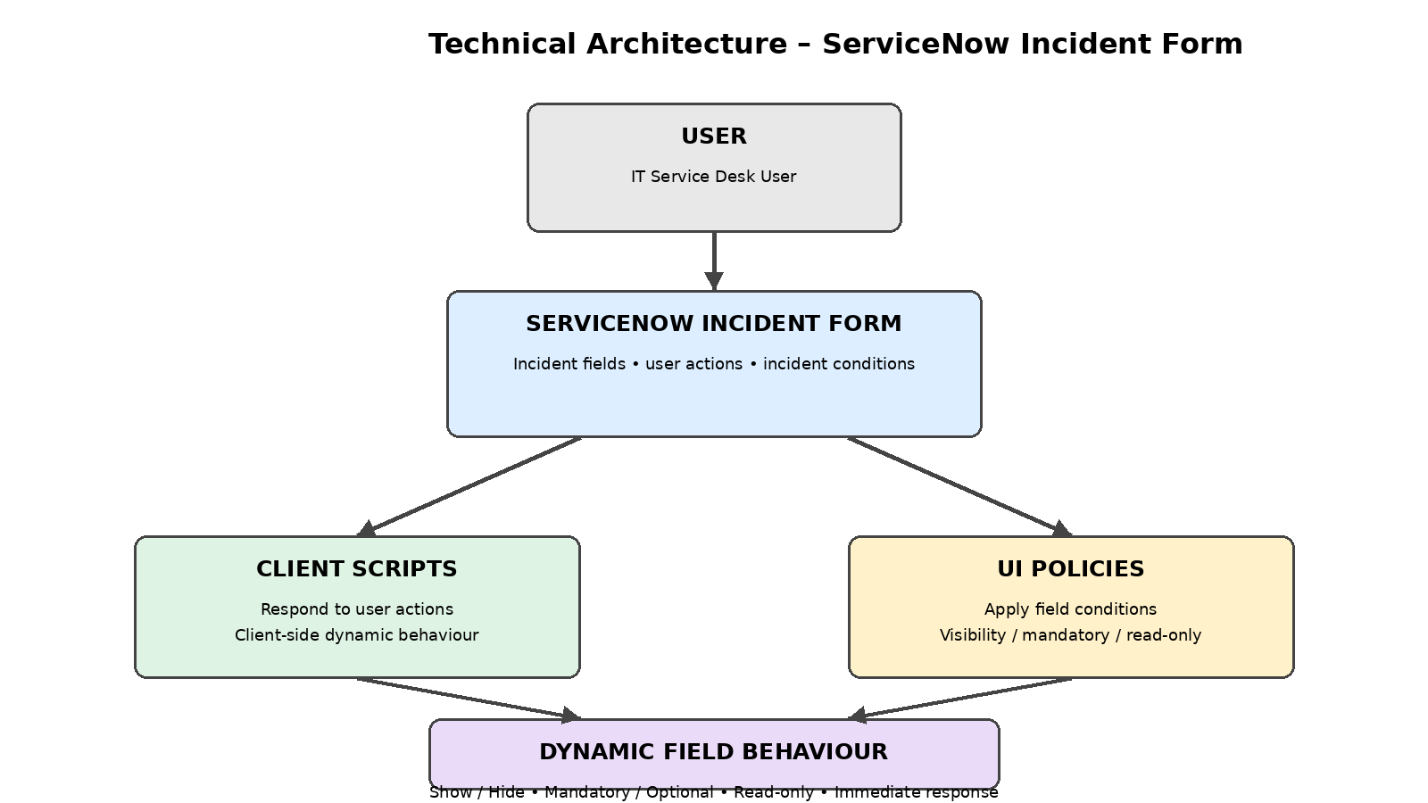
Project scope represented in the architecture: Client Scripts and UI Policies dynamically control Incident form fields based on user actions and incident conditions without requiring form submission.
Table-1 : Components & Technologies:
S.No | Component | Description | Technology
1 | User Interface | How the user interacts with the application through the Incident form. | ServiceNow Incident Form
2 | Application Logic-1 | Client-side logic that responds to user actions and changes form behaviour. | ServiceNow Client Script
3 | Application Logic-2 | Controls field behaviour based on defined Incident conditions. | ServiceNow UI Policy
4 | Application Logic-3 | Immediate dynamic form response without requiring form submission. | Client-side form behaviour
5 | Database | Incident records and configured form data are handled within the ServiceNow platform. | ServiceNow platform data store
6 | Cloud Database | Separate cloud database is not specified for this project. | Not applicable
7 | File Storage | Separate file-storage service is not specified for this project. | Not applicable
8 | External API-1 | No external API is specified in the project description. | Not applicable
9 | External API-2 | No external API is specified in the project description. | Not applicable
10 | Machine Learning Model | No machine learning model is specified for this project. | Not applicable
11 | Infrastructure (Server / Cloud) | The project is implemented within the ServiceNow environment. | ServiceNow platform
Table-2: Application Characteristics:
S.No | Characteristics | Description | Technology
1 | Open-Source Frameworks | No separate open-source framework is specified in the project description. | Not specified
2 | Security | Access and security controls are provided through the ServiceNow platform; no additional controls are specified in the project description. | ServiceNow platform controls
3 | Scalable Architecture | The implementation uses ServiceNow form-level Client Scripts and UI Policies. A specific multi-tier or microservices architecture is not specified. | ServiceNow platform
4 | Availability | The project operates within the ServiceNow environment. Specific load-balancing or distributed-server configuration is not specified. | ServiceNow platform
5 | Performance | Client-side field behaviour is designed to respond to user actions without submitting the form. | Client Scripts / UI Policies
References:
Technology Stack - Template (uploaded TNSDC template).
Project description supplied: Implement Client Script & UI Policy (Incident).

